Processing Field Spectroscopy Data using Spectragryph

2021
Andrew Gray
Operations Manage NERC Field Spectroscopy Facility
Contents
2. Inspect your spectra 2
3. Convert data to absolute reflectance 2
4. Interpolate 3
5. Exporting. 4
6. Averaging your data 4
Smoothing 5
Chopping out water absorption features 5

This guide will walk you through the process of taking the .sig files produced by an SVC 1024i Field Spectrometer, an .asd file produced by an ASD Field Spec spectrometer, or a .sed file created by a Spectral Evolution PSR series field spectrometer. It goes through converting data to absolute reflectance, interpolating to a 1 nm interval and exporting as a .csv file. It will also include some optional steps such as smoothing, averaging data and cutting out water absorption bands from your spectra.
Spectragryph is a fantastic bit of software developed by Friedrich Menges, that lets you easily view and manipulate a wide array of spectral files. It is available for free for personal and academic use from https://www.effemm2.de/spectragryph/
It works on Windows, Mac (through VirtualBox) and Linux (through wine). Please make sure you have the most up to date version of the software, as older versions will not natively read the SVC .sig files.

- After installing and starting Spectragryph, you can open your files by selecting the .sig (SVC spectrometer) or .asd (ASD spectrometer) files and dragging/dropping them into the empty graph pane. Alternatively use the open button and navigate to your folder containing spectral files, selecting and opening those you want to process.
  - If you have used a Spectral Evolution spectrometer, you will need to change the .sed file extension to .txt before you can load them in Spectragryph. To do this in batch in Windows use Powershell. First back up your spectrometer files(!) Press the Windows icon and type “Powershell”. Change to the directory with your files in by typing:

cd “PATH TO DATA”

then, copy and paste the following:

ls -filter *.sed | Rename-Item -NewName { [io.path]::ChangeExtension($_.name, "txt") }

You should now be able to open the .txt files directly in Spectragryph by dragging and dropping or through the open button.

Some spectra from a cloudy day:
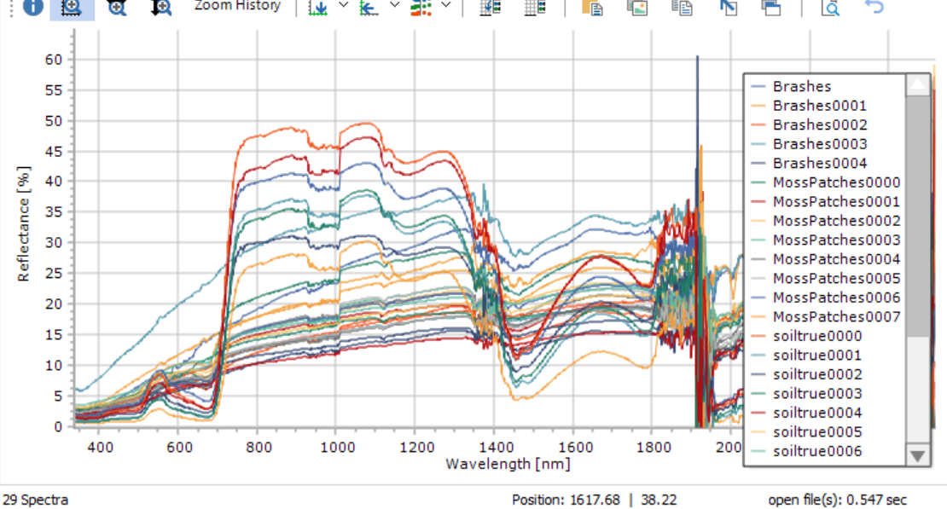

- Inspect your spectra. If there are any that you want to delete, press the delete button on the keyboard and select these files. Clicking on the graphed spectra highlights the filename in the legend.
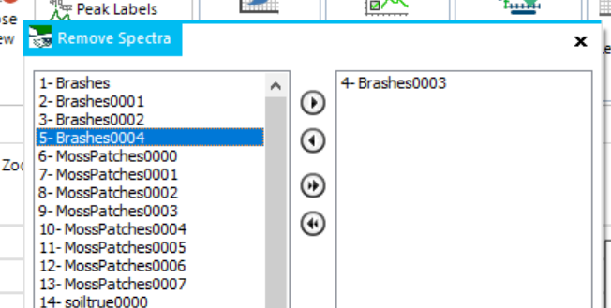

- Convert data to absolute reflectance. The first step is to convert your files from reflectance relative to the white panel used during field work to absolute reflectance. You can do this by multiplying your files by a reflectance calibration file.
  - Load your calibration file (if it is from us it will be in .xls or .csv format) You can download archive calibration files from https://fsf.nerc.ac.uk/calibration/cal_files.shtml If you have a .csv file you can load this in the same way as the .sig files. If you want to load a file for a single panel on the FSF calibration spreadsheet, select the column containing wavelength and then the column containing the data for your panel and paste them into a new sheet (as below) and save this sheet as a .csv, loading as per the .sig files. Make sure your calibration file is in 0-1 format, not 0-100% format.
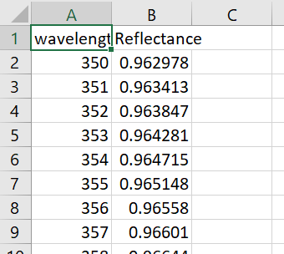
  - Multiply your field data by the calibration file. In the Transform Tab click on multiply. Select your panel calibration file in the “multiplied by: “ drop down box. Select “treat all spectra” and “remove originals” (this will only remove them from the graph pane, not delete the files)
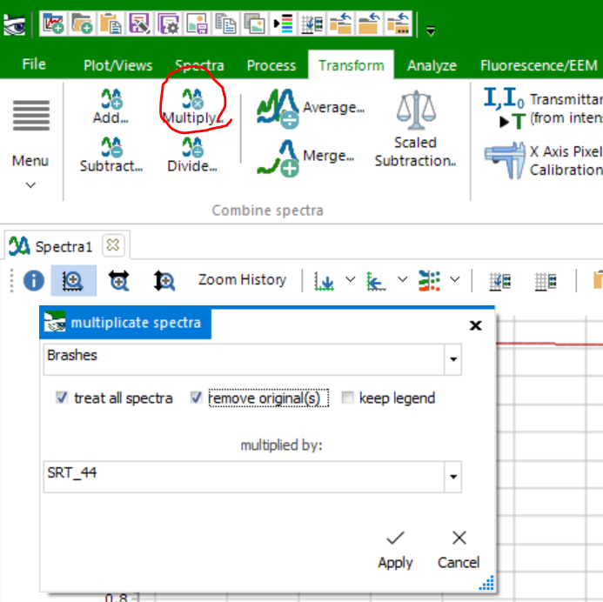
  - Click apply. This will process all of your files. The graph below shows the kind of change the correction applies in the VNIR when using a 99% reflectance Spectralon panel.
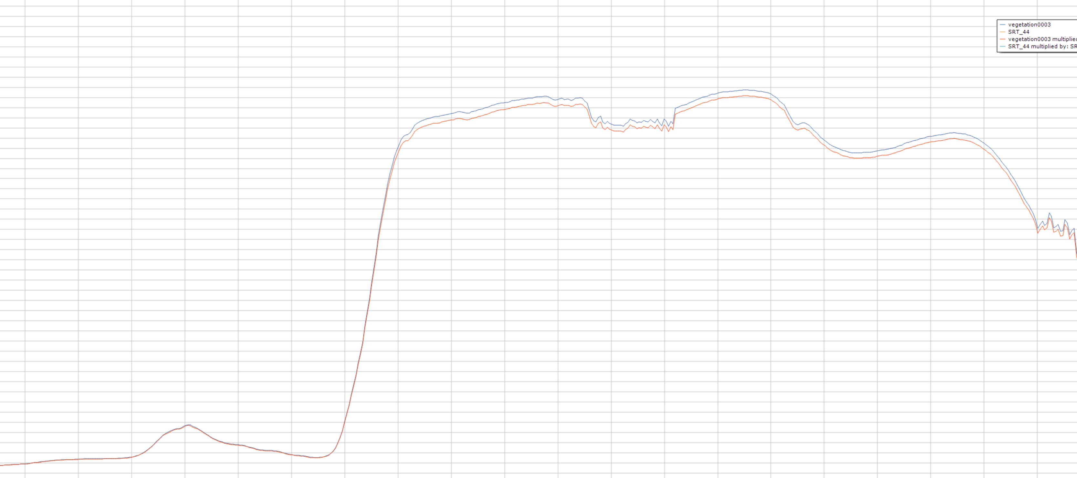

You can now remove your panel calibration file from the graph window using the delete key.

- Interpolate. The data from the spectrometer is not in 1 nm intervals. Because of this it won’t play nicely with some remote sensing software. You can interpolate your data using the 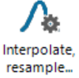 button in the Transform Tab. Click it and set it up as in the below image, changing the step width to 1nm, but keeping the start and end values. Press Apply
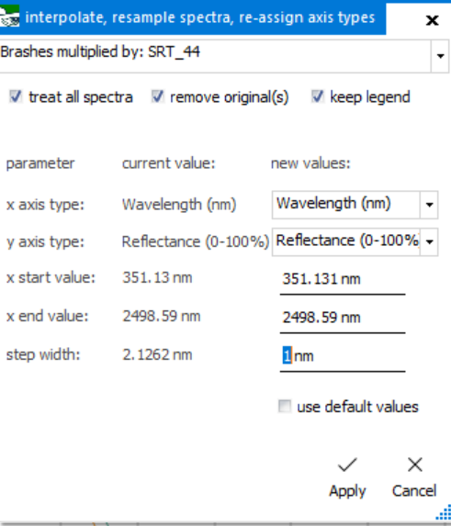

- Exporting. At this stage you may want to export your data into a .csv for further analysis. To do this, use the batch export button Change the format to .csv, export as a multifile to get all spectra into one file save in the same directory or choose a new one and come up with an informative name to call your file. See next image for file settings. Export your data!
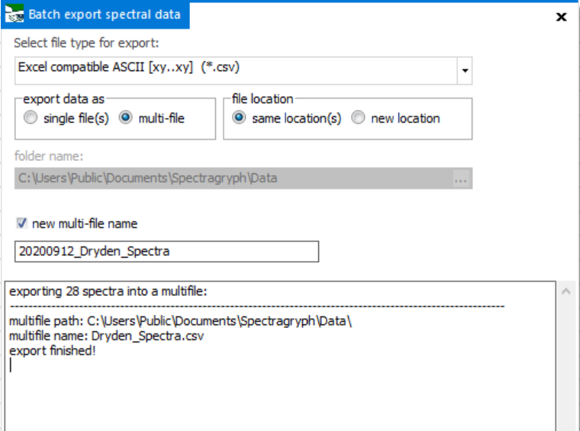

- Averaging your data by replicates of a single scene/object can also be done prior to exporting if you want to create a spectral library, for example. To do this click 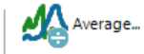in the Transform Tab. Select the files you want to average in the list of spectra and apply. You can then export as described above.

Easy!

Some additional processing:

Smoothing. In general, smoothing should be used as a last result. It is best ensure you have a good signal to noise at the point of data collection by optimising the setup of your spectrometer. However, in some low light conditions or low reflectance scenarios you may want to improve the quality of your spectra by applying Savitsky-Golay smoothing. You can do this easily in Spectragryph. Under the Processing Tab there is a button for it.
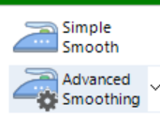

Chopping out water absorption features
As you can see in our spectra, there are some noisy patches around 1400 nm and 1900 nm. These relate to water in the atmosphere. As with smoothing, it is best to correct for these through experimental design: making sure you collect data on a sunny day at solar noon. Or using a contact probe. It is possible to remove these peaks, and interpolate over the removed section.
To do this, click the 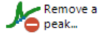button in the processing tab. Set the centre point and +/- values for the noise you want to remove and press apply.
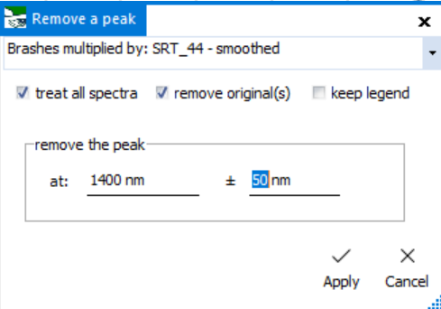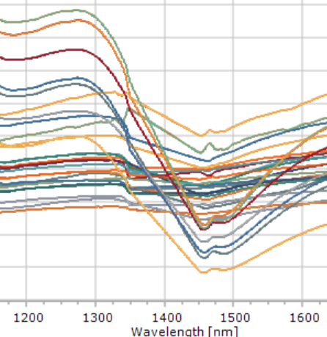

Spectragryph can do much more than this. Check out its manual here to learn more about its functions: https://www.effemm2.de/spectragryph/about_help_manual.html

